1. Create a S3 bucket, with no public access and upload files to the bucket 2. Launch two ec2 instances and connect it to an application load balancer, where the output traffic from the server must be a load balancer IP address.
2. S3 Bucket

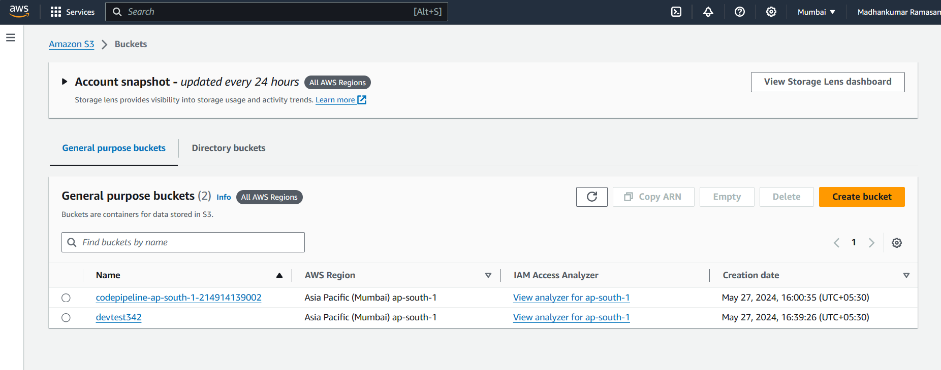

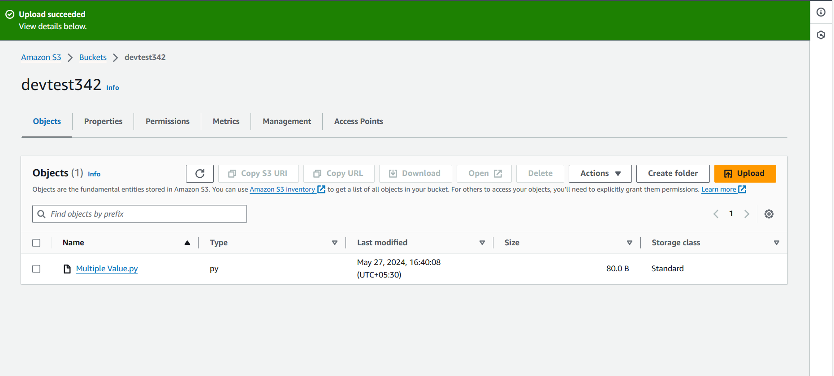

1. EC2 Instance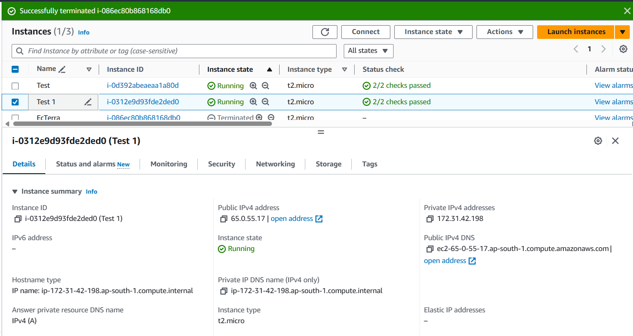

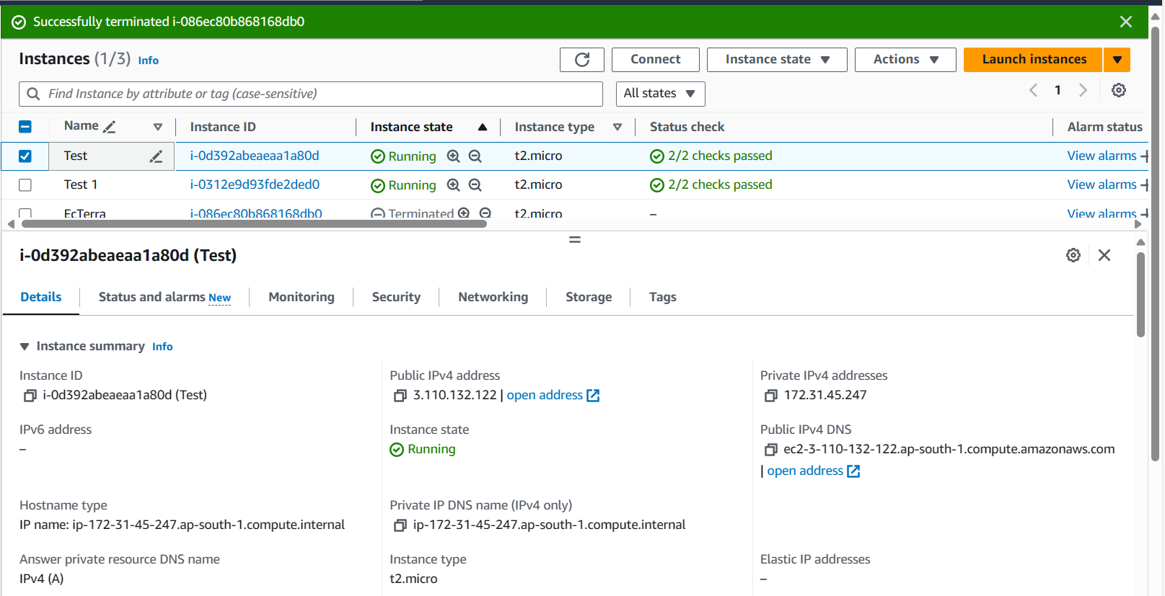

1. Target Group

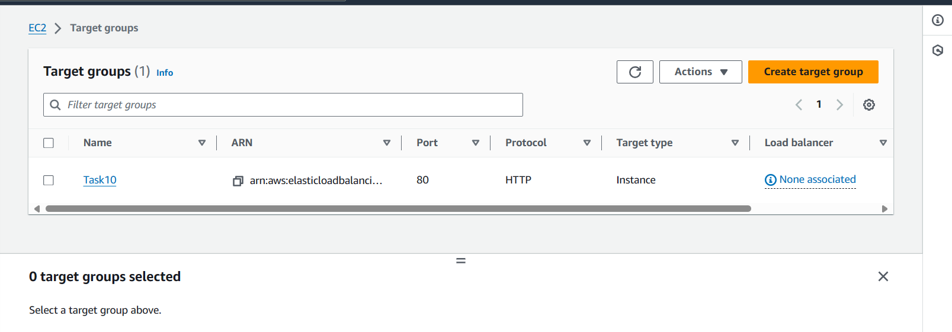

1. Load Balancer:

